Hybrid/ Electric Vehicle/ Battery Details Form
Please complete as much of this form as possible based on the vehicle logbook and a visual inspection of the vehicle/battery. This form can also be completed online at www.electricelves.ie.

If there is any evidence the vehicle/battery has been damaged, take additional care when assessing the vehicle/battery, traction batteries in hybrid/ electric vehicles contain significant voltage. Isolate the vehicle/battery from other ELV stock and ensure it is stored on a concrete pad. Take notes and photos of damage and contact ELVES for information on next steps straight away.

ATF Details:
ATF Name: |  |  |  |  | ATF contact number:
Contact Person: |  |  |  |  | Date of submission:
Vehicle Details:
Make: |  |  |  |  | Model:
Registration No: |  |  |  |  | CoD No:
VIN:
*Battery Reference No: |  |  |  |  | *Battery Serial No:
Identifying electric/hybrid vehicle marks
*These numbers can be found on the battery label. Please contact ELVES if you need assistance identifying these.
Is there any evidence/ knowledge of damage to vehicle/battery? Please tick ‘Yes’ or ‘No’
Battery damaged Yes: |  | No: |  | Details of suspected battery damage:
Vehicle damaged Yes: |  | No:
Details of suspected vehicle damage:
(e.g. Location of damage, knowledge of accident, gravity of damage)
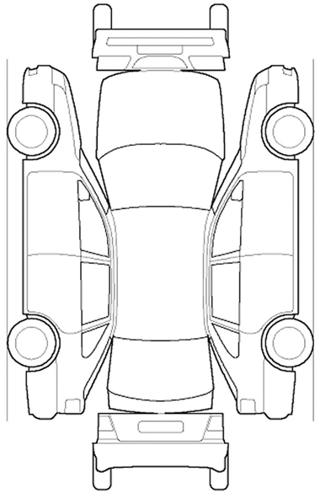

Please take photos of suspected damage to accompany this form
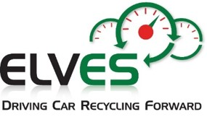
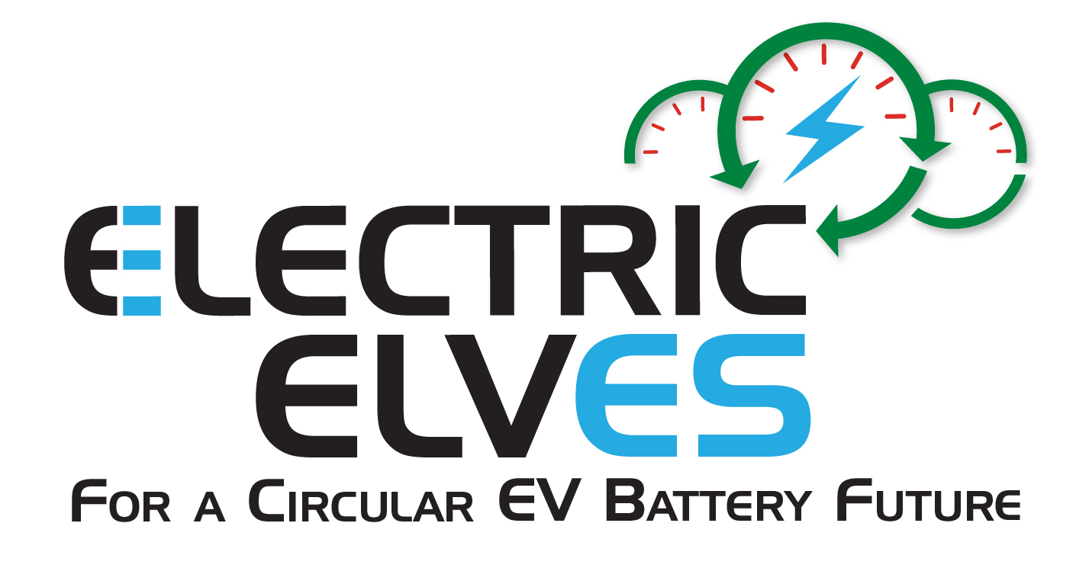
Contact ELVES for further assistance:
info@elves.ie, 041 983 5550
www.electricelves.ie

