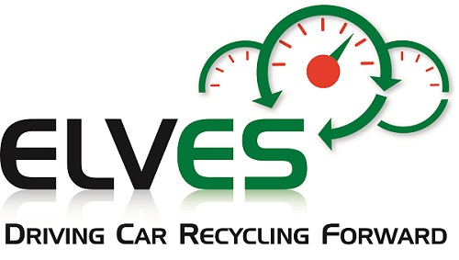

Mobile Air Conditioning
5N0106 Training

Application Form

☐ I would like to apply for a place on the Mobile Air Conditioning training (5N0106) provided by Limerick and Clare Education and Training Board.

The course will involve attending two Friday afternoon sessions, one online, the other in Shannon, Co. Clare. Training is expected to commence in May.

To confirm your space please complete and return this form to info@elves.ie or post to ELVES Unit 15-4, Workspace Centre, Drogheda, Co. Louth A92 E368

ELVES will be in touch to confirm places and timing of the training.

Name of Attendee:
Contact Number of Attendee:
Email Address:
ATF Name:
ATF Contact Number:

ELVES may take photos/video of the training events to help promote the pilot project and as a participant these may include your image.
I, ______________________________________________ (Insert Name) consent to my personal data (image and name) being used by ELVES for the purposes of promoting the AC Gases pilot project.
ELVES will hold this personal data on the basis of consent and as such you can withdraw this consent at any time by contacting us at info@elves.ie or ELV Environmental Services CLG, Unit 15-4, Workspace Centre, Mayoralty Street, Drogheda, Co. Louth, A92 E368. Your rights as per our Privacy Statement also apply. A copy of this Privacy Statement can be read online at www.elves.ie/privacy

